Eega and James started a new online zone for shopping called "Zencart". James has signed up "HoneyDew Designers" for creating their portal. In the shopping portal's login page, unique user names and passwords are generated for the registered users and those registration details are being maintained in a reliable database.  
The creative team of Honey Dew has assigned you to create a user login page with username field , password field with visibility disabled, phone number and email id. Apply various checks on form showing no blank fields where username’s length must be restricted from the range (6-8 alphabet) characters only, phone number must consist of only 10 digits (numeric data) and only a valid email id should be allowed to enter. When the client clicks on submit button , all the valid details must be correspondingly checked otherwise suitable error messages should be displayed. (10 marks)

Solution:

<!DOCTYPE html>

<html>

<body>

<script type='text/javascript'>

function formValidator(){

// Make quick references to our fields

var username = document.getElementById('uname');

var password = document.getElementById('pass');

var phoneno= document.getElementById('ph');

var email = document.getElementById('email');

if(lengthRestriction(username, 6, 8)){

if(isAlphabet(uname, "Please enter only letters for your name")){

if(isAlphanumeric(pass, "Numbers and letters should be used for password")){

if(isNumeric(ph, "Please enter a valid phone number")){

if(lengthRestriction(username, 10, 10)){

if(emailValidator(email, "Please enter a valid email address")){

{

return true;

}

}

}

}

}

}}

return false;

}

function notEmpty(elem, helperMsg){

if(elem.value.length == 0){

alert(helperMsg);

elem.focus(); // set the focus to this input

return false;

}

return true;

}

function isNumeric(elem, helperMsg){

var numericExpression = /^[0-9]+$/;

if(elem.value.match(numericExpression)){

return true;

}else{

alert(helperMsg);

elem.focus();

return false;

}

}

function isAlphabet(elem, helperMsg){

var alphaExp = /^[a-zA-Z]+$/;

if(elem.value.match(alphaExp)){

return true;

}else{

alert(helperMsg);

elem.focus();

return false;

}

}

function isAlphanumeric(elem, helperMsg){

var alphaExp = /^[0-9a-zA-Z]+$/;

if(elem.value.match(alphaExp)){

return true;

}else{

alert(helperMsg);

elem.focus();

return false;

}

}

function lengthRestriction(elem, min, max){

var uInput = elem.value;

if(uInput.length >= min && uInput.length <= max){

return true;

}else{

alert("Please enter between " +min+ " and " +max+ " characters");

elem.focus();

return false;

}

}

function emailValidator(elem, helperMsg){

var emailExp = /^[\w\-\.\+]+\@[a-zA-Z0-9\.\-]+\.[a-zA-z0-9]{2,4}$/;

if(elem.value.match(emailExp)){

return true;

}else{

alert(helperMsg);

elem.focus();

return false;

}

}

</script>

<form onsubmit='return formValidator()' >

User name: <input type="text" id="uname"> <br>

Password : <input type="password" id="pass"> <br>

Phone Number: <input type="text" id="ph"> <br>

email id:<input type="email" id ="email"> <br>

<input type='submit' value='Check Form' />

</form>

</body>

</html>

2) Using DOM , initially create an unordered list consisting of 3 Items and 4 buttons as shown in Figure: (10 marks)

i) clicking on replace button should replace “coffee” with “Water”.

ii) Clicking on Append button should append “Meat” at zeroth position.

iii) Clicking on Insert Before should “Lemon Tea” before “Tea”

iv) Clicking Remove should Remove “Lemon Tea”.

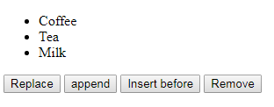

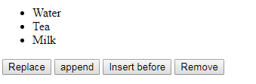

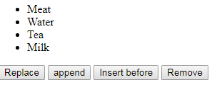

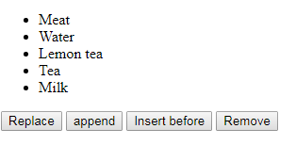

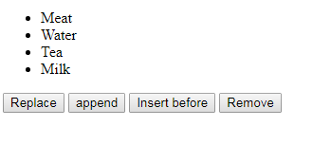

<!DOCTYPE html>

<html>

<body>

<ul id="myList"><li>Coffee</li><li>Tea</li><li>Milk</li></ul>

<button onclick="myFunction()">Replace</button>

<button onclick="myFunction1()">append</button>

<button onclick="myFunction2()">Insert before</button>

<button onclick="myFunction3()">Remove</button>

<script>

function myFunction() {

var textnode = document.createTextNode("Water");

var item = document.getElementById("myList").childNodes[0];

item.replaceChild(textnode, item.childNodes[0]);

}

function myFunction1() {

var newItem = document.createElement("LI");

var textnode = document.createTextNode("Meat");

newItem.appendChild(textnode);

var list = document.getElementById("myList");

list.insertBefore(newItem, list.childNodes[0]);

}

function myFunction2() {

var newItem = document.createElement("LI");

var textnode = document.createTextNode("Lemon tea");

newItem.appendChild(textnode);

var list = document.getElementById("myList");

list.insertBefore(newItem, list.childNodes[2]);

}

function myFunction3() {

var list = document.getElementById("myList");

list.removeChild(list.childNodes[2]);

}

</script>

</body>

</html>

Ques3) Design the following list: (5Marks)

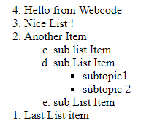

Solution:

<html>

<ol start="4" type="1" reversed>

<li> Hello from Webcode </li>

<li> Nice List ! </li>

<li> Another Item </li>

<ol type="a" start="3">

<li> sub list Item </li>

<li> sub <del> List Item </del> </li>

<ul> <li>subtopic1 </li>

<li> subtopic 2 </li>

</ul>

<li> sub List Item </li>

</ol>

<li> Last List item </li>

</ol>

</html>

Question4) Design the following table: (5 Marks)

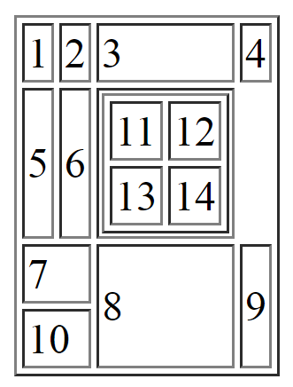

Solution:

<table border="1">

<tr>

<td> 1 </td>

<td> 2</td>

<td> 3</td>

<td> 4</td>

</tr>

<tr>

<td> 5 </td>

<td> 6 </td>

<td> <table border="1"> <tr>

<td> 11</td>

<td> 12 </td>

</tr>

<tr> <td> 13</td>

<td>14</td></tr>

</table>

</td>

</tr>

<tr><td colspan="2">7 </td>

<td rowspan="2">8</td>

<td rowspan="2"> 9</td>

</tr>

<tr> <td colspan="2"> 10 </td> </tr>

</table>

Ques5)

Write code snippet to change the HTML elements using JavaScript, the HTML DOM and events. (5marks)

i. On clicking over the text, the colour of the text should change to blue.

ii. As the mouse goes on the element, the text should become in Arial font.

iii. On double clicking the element the text should appear larger

Solution:

<!DOCTYPE html>

<html>

<body>

<p id="p1" onclick="f1()">Hello World!</p>

<p id="p2" onmouseover="f2()" ondblclick="f3()" >Hello World!</p>

<script>

function f1()

{

document.getElementById("p1").style.color = "blue";

}

function f2()

{document.getElementById("p2").style.fontFamily = "Arial";

}

function f3()

{

document.getElementById("p2").style.fontSize = "larger";

}

</script>

<p>The paragraph above was changed by a script.</p>

</body>

</html>

Question6) Consider an array named fruits = ["Banana", "Orange", "Apple", "Mango"] (5 marks)

a) Join the elements of an array using “*” symbol.

b) On click of a button add “Kiwi” on the last position in an array “fruits”.

c) On click of another button “lemon” should be added on the zeroth position in the same array.

<!DOCTYPE html>

<html>

<body>

<p id="demo"></p>

<button onclick="myFunction()" >Try it</button>

<button onclick="myFunction1()" >Try itt</button>

<script>

var fruits = ["Banana", "Orange", "Apple", "Mango"];

document.getElementById("demo").innerHTML = fruits.join(" * ");

function myFunction() {

fruits.push("Kiwi");

document.getElementById("demo").innerHTML = fruits;

}

function myFunction1() {

fruits.unshift("Lemon");

document.getElementById("demo").innerHTML = fruits;

}

</script>

</body>

</html>

1. Q1 Which attribute you’ll use with TD tag to merge two cells horizontally?

(i) merge=colspan2 (ii) Rowspan=”2”

(iii) merge=row2 (iv) Colspan=”2”

Q2. Consider the following snippet code

var string1 = ”123”;

var intvalue = 123;

alert( string1 + intvalue );

The result would be

|  |  |  |  |
| --- | --- | --- | --- |
| (i) | 123246 | (ii) | 246 |
| (iii) | 123123 | (iv) | Exception |

Q3 _________is the correct syntax for creating a radio button in a form.

|  |  |  |  |
| --- | --- | --- | --- |
| (i) | <radio button> | (ii) | <input type=”radio”> |
| (iii) | <input=radio> | (iv) | <input radio button> |

Q4 Which are the special tags used for image mapping?

|  |  |  |  |
| --- | --- | --- | --- |
| (i) | map and area | (ii) | map and usemap |
| (iii) | Only map | (iv) | Only area |

Q5 To specify table border in CSS, ____________ property is used.

|  |  |  |  |
| --- | --- | --- | --- |
| (i) | tbl-border | (ii) | table-border |
| (iii) | tb-border | (iv) | Border |

Q6 Consider this statement var cars = new Array("Saab", "Volvo", "BMW"); . What will typeof cars return?

|  |  |  |  |
| --- | --- | --- | --- |
| (i) | Object | (ii) | Array |
| (iii) | String | (iv) | None of these |

Q7 How to find the index of a particular string

i) Position ii) index

iii)indexOf() iv) none

Q8 Two String Objects when compared with = = operators’ returns

|  |  |  |  |
| --- | --- | --- | --- |
| (i) | True | (ii) | False |
| (iii) | Cannot compare | (iv) | None of the above |

Q9 Which one is the correct way to access data of HTML Element.

|  |  |  |  |
| --- | --- | --- | --- |
| (i) | Document.getElementByClass() | (ii) | Document.getElementByTagname() |
| (iii) | Document.getElementById() | (iv) | All of these |
|  |  |  |  |

Q10 How is everything treated in HTML DOM?

|  |  |  |  |
| --- | --- | --- | --- |
| (i) | Nodes | (ii) | Attributes |
| (iii) | Elements | (iv) | All of these |